EC Cycles 2 UP and Solo 10 Mile Time Trial
Sunday 10th March 2013
Promoted for and on behalf of Cycling Time Trials under their rules and regulations.

Event Headquarters and Parking
TRW Club Resolven– Available from 8:30am
Address: TRW Club Resolven,
Neath,
West Glamorgan,
SA11 4HN

Course Description—R10/22a
Revised 17/01/2013 by Norman James
Start on Vale of Neath Supplier Estate service road opposite Lamp Post No. 18.
Proceed along service road to Resolven roundabout (0.5miles).
(N.B. Safety Notice:- Do not cross the centre-line of road on right hand bend)
Take 1st exit left along A465 dual carriageway westbound to 1st Exit left (4.862 miles).
Continue up the loop to Tonna roundabout where take 1st exit to Aberdulais Interchange.
Take 4th exit (5.5 miles) down slip road to re-join A465 dual carriageway.
Proceed eastbound to Resolven roundabout where take 1st exit left to finish at access road to Canal Car Park on cross-valley link road (10 miles).
H.Q. 282500 East 202660 North
Start 282450 East 202250 North
Turn 277000 East 199000 North
Finish 282670 East 203100 North

Safety
The Police have requested that inconvenience to the public and other road users be kept to a minimum. Riders are asked to take great care and, in particular, note the following points:
To avoid congestion at the start please queue in single file.
Please do not make “U” turns at either the start or finish.
Please be considerate to other road users including other riders.
Please take care at all the roundabouts and junctions
Dangerous riding will result in disqualification. Please keep your head up for a safe ride. Cycling Time Trials recommends that competitors wear a hard shell helmet that meets an internationally accepted standard. All junior/juvenile riders MUST wear protective hard shell helmets.
Numbers
Race numbers will be available from the HQ. A drink will be available at HQ on return of your number.
Competitors clothing for the 2 Up TT
To assist the timekeepers and other officials, riders from each team should wear similar jerseys.
Prizes
Fastest 2 Up Team Time Trial - £20
First Male Solo Overall - £20
Second Male Solo Overall - £15
Third Male Solo Overall - £10
First Female Solo Overall - £20
Second Female Solo Overall - £15
Third Female Solo Overall - £10
Fastest Veteran - £10
Event Secretary
Lyn Jones
11 Camellia Close,
Aberdare,
RCT,
CF44 8YE
Timekeepers
Robin Field
Tudor Thomas

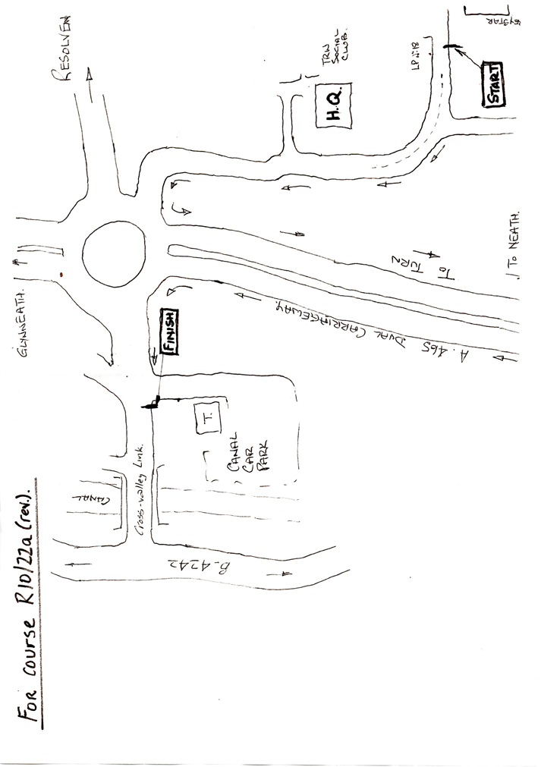
Celtic Series 2013
This event is part of the Celtic Series, a series of mostly mid-week time trials that are taking place in South Wales this spring and summer. There are 5 events in the series, and to complete the series you need to do at least 4 of the events. There 4 remaining events in the Series it would be fantastic if you could join us!

Event 2 - R10/16a on Saturday 23rd March (promoted by Cardiff Ajax)
Event 3 - R10/16a on Tuesday 14th May (promoted by Cwmcarn Paragon)
Event 4 - R10/9 on Tuesday 11th June (promoted by Ogmore Valley Wheelers)
Event 5 - R10/16a on Tuesday 18th June (promoted by Cwmcarn Paragon)

Points are awarded over the Series, there are individual and team competitions, plus an award for completing the series.
All events can be entered online using the CTT website.

If you would like to do the rest of the Series we have made your life easier, you can post a CTT Entry form with a cheque made out to ‘Celtic Series’ for £32.50 to Becky Aicheler, 6 Llyswen, Machen, Caerphilly, CF83 8PA.

Please check out our website for information www.CelticSeries.co.uk
We also have a Facebook page (Celtic Series) and twitter feed @CelticSeriesTT

